[https://1913578542.rsc.cdn77.org/images/logo.png](https://www.tourism-of-india.com/)

* [Home](https://www.tourism-of-india.com/)
* [Packages](https://www.tourism-of-india.com/india-tour-packages/)
* [Destination](https://www.tourism-of-india.com/travel-destinations.html)
* [Experiences](https://www.tourism-of-india.com/things-to-do/)
* [Best Time To Visit](https://www.tourism-of-india.com/best-time-to-visit-india/)
* [International](https://www.tourism-of-india.com/international-tours/)
* [Get Quote](https://www.tourism-of-india.com/ladakh/things-to-do/lakes-ladakh.html)

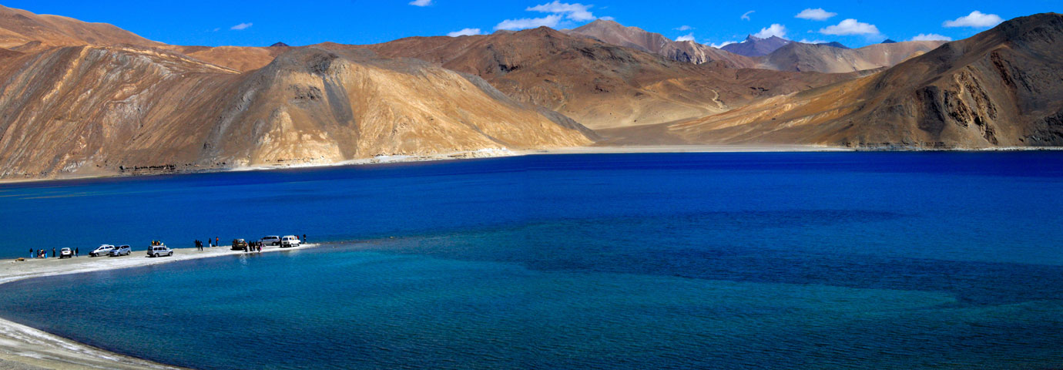

1. [Home](https://www.tourism-of-india.com/)

1. [Destinations](https://www.tourism-of-india.com/travel-destinations.html)

1. [Jammu & Kashmir](https://www.tourism-of-india.com/jammu-kashmir/)

1. [Ladakh](https://www.tourism-of-india.com/ladakh/)

1. Lakes

Lakes in Ladakh

A cold desert and the land of high-altitude mountain passes, Ladakh has been blessed with breathtaking landscapes including its glistening crystal clear lakes. Lakes in Ladakh are called Tso. In the decent landmass that it owns, Ladakh has a number of stunning lakes. The best time to visit these lakes is between the months of May and September as during the winter months, these high-altitude lakes get frozen. Here are the popular lakes of Ladakh:

Pangong Tso

World’s highest salt lake, **[Pangong Lake](https://www.tourism-of-india.com/jammu-kashmir/things-to-do/pangong.html)**is the most popular lake of Ladakh that is around 160 km from Leh. India owns only one-third of this lake, the rest of it is in Tibet, a region controlled by China. This endorheic lake is placed at an altitude of around 14,270 feet. The length of the lake is 134 km and it is positioned on the Changtang plateau in eastern part of Ladakh.

Also known as the ‘Hollow Lake’, its brackish water appears in different colors fur to sunlight. The lake and its surroundings are truly magical and simply mesmerizing. During winter season, the lake gets frozen, hardened like a road. This lake then becomes the venue of a gala festival of ice skating, which is attended by a huge number of skiers from all around the world. The area of lake is under the Indian army. While Indian nationals do not need any permit to visit the lake, foreign tourists require a permit that can be obtained for a small fee from deputy commissioner of Leh.

Drive via the attractive and serene countryside, through the world’s third highest motorable mountain pass- Chang La to arrive at the lake. The best time to Pangong Tso is from June to September.

[**[+] Read More**](https://www.tourism-of-india.com/ladakh/things-to-do/lakes-ladakh.html)

Tso Moriri

Lake Moriri or Tso Moriri is a lake in the Changthang area, and is positioned at an altitude of 15,075 feet in [**Jammu and Kashmir**](https://www.tourism-of-india.com/jammu-kashmir/). This lake is positioned amid Ladakh to the North, Zanskar to the West and Tibet to the East. It is one of the largest of the high- altitude lakes in the Trans-Himalayan region in India. Korzok village is another popular attraction here.

Fed by 2 streams and springs, Tso Moriri in 2002 was declared a Wetland of International Importance under the Ramsar Convention. It is also fed by melting water from the closely placed ice masses. The lake, home to a vast variety of flora and fauna, is 19 km in length and 7 km in width. The lake gets completely freezes in the winter months and you can even walk on it. Bird watching is a popular activity here as the lake attracts as many as 34 avifauna species.

[**[+] Read More**](https://www.tourism-of-india.com/ladakh/things-to-do/lakes-ladakh.html)

Tso Kar / Tsho Kar

Connected by a small stream, Tso Kar can be termed as a twin lake as the western part of the lake has salty lake and the eastern part contains fresh water. Placed in the southern Ladakh, this vacillating salt lake lies in Rapshu and varies in size as well as depth. In the summer while it stays up to around 30 degree Celsius, in winters it falls down as low as 40 degree Celsius.

An inlet stream connects Tso Kar with Startsapuk Tso from its south-west end. Looking like plain pools, these two lakes are guarded by 2 peaks, Thugje and Gursan. A few years ago, this lake was an important source of salt that was exported to Tibet by Changpa nomads. Visitors can opt for tented camps on the western banks of the lake. The nomadic settlement of Thugje is another option. It is located 3 km northwards of Tso Kar.

[**[+] Read More**](https://www.tourism-of-india.com/ladakh/things-to-do/lakes-ladakh.html)

Yarab Tso Lake

Located at a distance of around 15 km from Diskit region of Nubra Valley, Yarab Tso Lake is surrounded by the scenic village of Sumur. An uphill walk of around 15-20 minutes from the Panamaik village takes you to the stunning site of this lake.

One of the high-altitude lakes in **[Nubra Valley](https://www.tourism-of-india.com/nubra-valley/)**, Yarab Tso Lake is also known to be a sacred lake. On the crystal clear water bed of the lake, you can view the barren and rocky landscape of the surrounding area.

Mirpal Tso

Tranquil and completely secluded, Mirpal Tso is placed close to Chusul. The southern end of this lake contains fresh water and the lake’s bed is sandy.

Chagar Tso

Located on the way to Pangong Lake, Chagar Tso is one more beautiful lake in Ladakh. Though the lake is small but it is worth-visiting.

Kyun Tso and Ryul Tso

Located near Hanle and Nyoma, the twin lakes of Kyun Tso and Ryul Tso, are located at an altitude of around 5000 m above the sea level. Kyun Tso is also called chilling Tso. As the route to this lake is difficult and also permits are required to visit it, very little tourists come here. Mahe - Nyoma - Nidar - Thit Zarbo La is the way to these twin lakes.

Kiagar Tso

Placed on the way to Tso Moriri, Kiagar Tso is another striking lake of the region and lies in the Changthang plateau. The surroundings of the lake are the dwellings of Changpas, the nomadic people of Ladakh. Tso Moriri and Kiagar Lake are 10 km away from each other.

Kiagar Tso or Kyaghr Lake is 3 km long, 22 m deep and 1.5 km wide. This lake with brackish water the place where a number of trekkers halt before moving forward to Kiangdum camping ground near the Tso Moriri. The site is 22 km away from here. The lake lies enroute Ladakh to Spiti in the Himachal Pradesh state.

Stat Tso and Lang Tso

Placed in the **[Zanskar](https://www.tourism-of-india.com/zanskar/)** region of Ladakh, Stat Tso and Lang Tso are twin lakes that are placed close to the hughest point in Zanskar,

[https://1913578542.rsc.cdn77.org/images/logo.png](https://www.tourism-of-india.com/)

* [Home](https://www.tourism-of-india.com/)
* [Packages](https://www.tourism-of-india.com/india-tour-packages/)
* [Destination](https://www.tourism-of-india.com/travel-destinations.html)
* [Experiences](https://www.tourism-of-india.com/things-to-do/)
* [Best Time To Visit](https://www.tourism-of-india.com/best-time-to-visit-india/)
* [International](https://www.tourism-of-india.com/international-tours/)
* [Get Quote](https://www.tourism-of-india.com/ladakh/things-to-do/trekking-ladakh.html)



1. [Home](https://www.tourism-of-india.com/)

1. [Destinations](https://www.tourism-of-india.com/travel-destinations.html)

1. [Jammu & Kashmir](https://www.tourism-of-india.com/jammu-kashmir/)

1. [Ladakh](https://www.tourism-of-india.com/ladakh/)

1. Trekking

Trekking in Ladakh

Adorning the crown of India, the Leh and Ladakh regions are like a heaven that glorify the country with its most scenic locations, sights and views. The region is permeated with majestically towering high mountains, breathtaking steep snowy slopes, vast and limitless expanses of dry and barren deserts, small but spectacular green pastures and exotic and simple everyday life of the local people. Trekking in Ladakh is surely a thrilling experience.

With such an incredible wealth characterizing the place, the region is one of the most suitable and best places to enjoy trekking and other major adventure activities. Find as we mention below some of the best treks in Ladakh region and plan an incredible hike through the stunning treasures that nature has to offer here. And whether you believe it or not, this will be one of your most memorable expeditions of the lifetime.

[**[+] Read More**](https://www.tourism-of-india.com/ladakh/things-to-do/trekking-ladakh.html)

Markha Valley Trek

A hike full of diverse scenic views, Markha Valley Trek is one of most famous treks in the Ladakh region. Like a green oasis in the midst of vast dry deserts, the pathways are full of most magnificent landscapes and astonishing sights, providing a real treat to the eyes. En route, one comes across beautiful small villages, , charming shepherd camps and high passes, particularly the Gandala La (4,800 m) and Kongmaru La (5,150 m) taking you through a dreamy region, fancied only through pictures and impressions.

The trek through the Markha valley begins from Spituk which then takes you through the region south-west of Indus, until the trekker reach its confluence with the river Zinchen. As one moves further, other majestic sights including those of captivating streams, valley and that of Kangyatze Peak, awaits the traveler. Thus, there is something new to explore every day in this amazing hike which keep you thrilled and awestruck all throughout the journey.

* Duration: 9 days
* Highest point: Kongmaru La (5135 m)
* Difficulty: Moderate

[**[+] Read More**](https://www.tourism-of-india.com/ladakh/things-to-do/trekking-ladakh.html)

Henaskut to Wanla

There is no dearth of incredible sights in Ladakh, which is widely known within the travelers’ community as a hiking paradise. The said trek begins from the village of Henaskut, situated at a distance of 160 kilometers from Leh. Moving through many picturesque locations the trekkers gets to climb several passes such as Niyiguste La, Yogmala, Pirkiting La. The trek then finally finishes at the quaint village of Lamayuru. Here, the oldest monastery in Ladakh by the same name is a major attraction.

Although this incredible trek has been described to be of moderate difficulty, yet the views are most breathtaking for the delight of the eyes. The best time to undertake this picturesque hike is between June and October when the weather as well as physical conditions are most appropriate for a safe expedition.

* Duration: 6 days
* Highest point: Nyigutse La (5000 m)
* Difficulty: Moderate

[**[+] Read More**](https://www.tourism-of-india.com/ladakh/things-to-do/trekking-ladakh.html)

Tsomoriri to Kibber

The trek situated alongside the Tsomoriri Lake is full of most excellent views and passes its way through several monasteries where one may come across numerous monks and locals. However, scenic views of the surroundings notwithstanding, tourists come across amazing warm hospitality of the locals that make the journey all the more enjoyable and comfortable. There are diverse landscapes through which the path crosses-from beautiful lakesides to rough and rocky terrains.

The trek normally takes around 7-8 days while the difficulty level of the journey has been described from easy to moderate. Nevertheless, the trek is a great way to experience the thrill and excitement of a mountain hike and together with the heavenly surroundings of Ladakh region makes the expedition holistically cherishing to your heart.

* Duration: 7-8 days
* Highest point: Parang La (5580 m)
* Difficulty: Moderate

[**[+] Read More**](https://www.tourism-of-india.com/ladakh/things-to-do/trekking-ladakh.html)

Hemis to Zangla by Junglam

Open between the months of June and October, this trek can be alternatively started from three villages-The Martsalang, The Hemis and The Zengchan. Even though described as moderate, the trek requires at least a couple of days of acclimatization for the travelers to comfortably undertake the trek. The route takes you through several different landscapes, crossing many paths, streams and passes.

The course of the trek enters the famous Markha valley from the Junglam pass affording at all times wonderful views which keep you mesmerized. The highest point of this trek is Charchar La which is located at the height of approximately 4,950 m above sea level.  The path is closed to visitors in summers due to water crossing while in winter heavy snowfall blocks the same path, inhibiting any expedition.

* Duration: 9 days
* Highest point: Charchar La (4950 m)
* Difficulty: Moderate

[**[+] Read More**](https://www.tourism-of-india.com/ladakh/things-to-do/trekking-ladakh.html)

Sham Trek (Liker to Khaltse)

The trek passes through several charming villages and picturesque locations, letting you experience the great fun and adventure of an amazing mountain hike as well as understand the unique Ladakhi culture. It is also considered one of the easiest treks and is populated throughout the route with several beautiful and important monasteries such as Shey, Thiksey, Spituk, Hemis and many more.

The trek is best for beginning trekkers as the height of all the passes on the route does not exceed beyond 4,500m. The panoramic views are wonderfully photogenic and captures the charming rural life of the area. The trekkers can also have the opportunity to live in a local house to experience the real allure and ways of life of the simple hearted villagers. Thus, trekkers with shorter time on their schedule can plan this hike to have a great mountain adventure.

* Duration: 5 days
* Highest point: Tsermangchan La (3750 m)
* Difficulty: Easy

[**[+] Read More**](https://www.tourism-of-india.com/ladakh/things-to-do/trekking-ladakh.html)

Lamayuru to Darcha trek

A relatively longer trek, this hike begin from the beautiful Lamayuru monastery and during the first half of the excursion enter Zanskar from the isolated villages of Lingshet, Padum, Photoksar. The trek has been assigned moderate difficulty level and is one of the best options for those who take pleasure in thrilling adventures as well risks of nature. But that’s not all, the trek takes you through the real picturesque beauty of Ladakh, with imposing hills and majestic vales.

It is the expedition that cover several number of passes. The trek then finally concludes at Darcha in Himachal Pradesh. The best time to undertake this incredible expedition is between the months of June and October. This fun and adventure filled 19 day trek is surely to generate a lot excitement and will be etched in your memory for a long time.

* Duration: 19 days
* Highest point: Shinkhul La (5080 m)
* Difficulty: Moderate

[**[+] Read More**](https://www.tourism-of-india.com/ladakh/things-to-do/trekking-ladakh.html)

Lamayuru to Hemis

Again commencing from the charming Lamayuru Monastery, this amazing hike passes through numerous locations of virgin beauty like the famous Ripchar Valley as well as the several nomadic inhabitations and verdant pastures. Treading through several mountain passes, the trekker comes across stunning sights, including those of Zanskar and Karakoram ranges. The initial leg of the trek concludes in Chilling Village and from here the adventurers are made to cross the river on a cable car. Thereafter, the journey continues into the Markha Valley, one of the most beautiful locations in Ladakh.

The path also takes you to numerous settlements and vast lush fields, the views of which are almost like a piece out of some fantastical world. Crossing through several rivers, gorges, passes and pastures, a traveler comes across Sakyapa Sect monastery from where spectacular glimpse of the entire valley is visible. This amazing expeditions takes nearly 15 days to complete and passes through Kongmaru La, which is the highest point in the trek located at an altitude of 5,135 m above sea level.

* Duration: 15 days
* Highest point: Kongmaru La (5135m)
* Difficulty: Moderate

[**[+] Read More**](https://www.tourism-of-india.com/ladakh/things-to-do/trekking-ladakh.html)

Chader Trek

One of the most challenging treks for hikers, the Chadar trek opens only for about a month (i.e. Jan-Feb) when the famous Zanskar River ( a tributary of the Indus River) gets frozen with solid ice. Located at an altitude of approximately 10,900 ft. above sea level, the weather during the trek is extremely cold and one needs a thorough preparation before embarking on this hike.

The word “Chadar” is used to denote the blanket of ice that covers the entire stretch of the journey, which spans nearly 100 kilometers. Although taking nearly 11-30 days to complete, trekkers can spend some time in the home of the locals and eat the unique ladakhi food. But, no matter how hard the trek is and how harsh the conditions may be, it is certainly one of the most memorable expeditions you will ever undertake.

* Duration: 11-30 days
* Highest point: Lingshet
* Difficulty: Challenging

[**[+] Read More**](https://www.tourism-of-india.com/ladakh/things-to-do/trekking-ladakh.html)

Rumtse to Tsomoriri

This trek begins from Rumtse which is located at a distance of 85 kilometers from Leh. The trek passes through many varied landscapes and takes about 7-8 days to complete. This trek has also been placed in the category of challenging hikes. Rumtse to Tsomoriri Trek lets you come face to face with the majestic Tsomoriri Lake that spans nearly 120 square kilometers in area.

During the expedition, one has to pass through seven mountain passes, approximately 10 river crossings and innumerable heavenly landscapes that one can only imagine in most wild fantasies. The trek has an amazing Tibetan feel throughout the whole excursion. On the way, one may come across many exotic, different species of birds and wild animals such as bar necked geese, black-necked crane and Brahminy duck, Kyang (wild ass), marmots, blue sheep, Himalayan Ibex as well as snow leopards.

* Duration:7-8 days
* Highest point: Yalang Yugula (5440m)
* Difficulty: Challenging

[**[+] Read More**](https://www.tourism-of-india.com/ladakh/things-to-do/trekking-ladakh.html)

Saboo to Khaltsar

The trek starts from the Saboo village, which is placed at a distance of 7 kilometers from Leh. The trek is divided into two phases. In the initial phase, the trekker get to explore the beautiful Nubra valley, walking via Digar La, which also the highest point in the whole trek, located at an altitude of 5,300 meters above sea level. This point also forms a wonderful vantage point from where beautiful sights of many different monasteries, villages, monks and local people could be seen. Also the incredible view of Karakoram Range and Saser Khangeri are also visible from this point.

The second phase of the trek includes walking towards Khalsar, along the charming Shyok River. The trek, although full of unique, picturesque sights, is of moderate difficulty. The best time to undertake this wonderful trek is from July to September.

* Duration: 5 days
* Highest point: Digar La (5300m)
* Difficulty: Moderate

[**[+] Read More**](https://www.tourism-of-india.com/ladakh/things-to-do/trekking-ladakh.html)

Hemis to Takh

Commencing from the fascinating Hemis Monastery, the trek begins by walking for about a day till the trekkers enter the picturesque Markha Valley where the travelers halt for the night stay. This trek too as also with other treks, passes through many villages and passes. The hike has been described as challenging as the highest point (Kongmaru) lies at a phenomenal altitude of 5,135 meters above sea level.

After a wonderful expedition, that takes you through so many scenic locations, the trek finally concludes at Juktah, which is situated on the Leh-Manali Highway. The best time to attempt this hike is from June to October as the conditions and weather at this time are most suitable for an ideal experience.

* Duration: 12 days
* Highest point: Kongmaru La (5135m)
* Difficulty: Challenging

[**[+] Read More**](https://www.tourism-of-india.com/ladakh/things-to-do/trekking-ladakh.html)

Spituk to Stok

This hike is said to be favorite for wildlife enthusiasts as the route goes through the famous Hemis National Park. Besides the path leads to so many of diverse locations and landscapes such as remote villages, high passes as well as beautiful mountains of Rupsho. This is a relatively shorter hike (spanning only 3 days) and is open between June and October only. But nevertheless the highlight of this trek is the numerous exotic wildlife species that one comes across-Blue Sheep, the Great Tibetan Sheep, Snow Leopard, several mountain as well migratory birds as also the exquisite mountain flora.

The highest point on this trek is Stok La, placed at 4,900 meters above sea level and which commands breathtaking sight of the Indus Valley. Another interesting highlight of this trek is the visit to Stok Museum that showcases rare heritage of the Ladakhi rulers.

* Duration: 3 days
* Highest point: Stok La (4900m)
* Difficulty: Moderate

[**[+] Read More**](https://www.tourism-of-india.com/ladakh/things-to-do/trekking-ladakh.html)

Hemis to Tsomoriri

This challenging though picturesque trek lets you soak in the beauty of myriad of landscapes. The trekker comes across several remote villages, numerous steep climbs and many beautiful green pastures. Beginning with the famous Hemis monastery, the path enters the Rupsho while crossing the highest point of Kongmaru (at a height of 5,135 meters). The area covered by the trek is a part of the famous Changthang Plateau, which is a part of the western Tibet and is called Eastern Ladakh.

Moreover, this area is also called the land of nomads as one comes across many tribes of nomads whereupon also witnessing their traditional and unique lifestyles. An interesting highlight of the area is that it is actually a wildlife sanctuary that houses many important albeit rare species of animals such as snow leopard, wild asses as well as many exotic species of birds such as the famous black necked crane.

* Duration: 10-15 days
* Highest point: Kongmaru La (5135m)
* Difficulty: Challenging

[**[+] Read More**](https://www.tourism-of-india.com/ladakh/things-to-do/trekking-ladakh.html)

Phyang to Hunder (Nubra Valley)

The beautiful Nubra Valley, lying towards North of Leh, was the gateway for the famous Silk Route and is naturally one of the most scenic locations. The trek commences from Phyang, located 23 kilometers west of Leh. The trek features wonderful vast expanses of stupendous landscapes and incredible views of the majestic Karakoram Range. A stunning highlight of the trek is the breathtaking ride over the highest motorable road in the world (5,606 m above sea level), which is usually undertaken on the last day of the hike.

Spanning through the entire eight days, the trek leaves you completely speechless and spellbound. The trek has been described as challenging and the highest point of the hike is La-Sermo, situated at a remarkable height of 5,150 meters above sea level. The expedition nevertheless remains a wonderful experience to undertake.

* Duration: 8 days
* Highest Point: La-Sermo (5,150 m)
* Difficulty: Challenging

[**[+] Read More**](https://www.tourism-of-india.com/ladakh/things-to-do/trekking-ladakh.html)

Lamayuru to Chilling Trek

This stunning trek affords never before experience of Ladakh as the trail passes through some of the most wonderful sights full of heavenly beauty and unique experiences. Abundant with most picturesque natural treasures, with snow covered paths, mesmerizing rivers and exotic villages. The path also lets you to enjoy astonishing views of the Stok and Karakoram ranges and the trail comes up and close with breathtaking passes, namely Prinkti La Pass, Dung Dung Chan La Pass and the Kongskil La Pass.

As one moves forward into the expedition, one comes across exotic flora and fauna as well as get to understand the unique lifestyles of the locals. Nevertheless, in case of Lamayuru to Chilling Trek, if you love trekking this is the hike that you should be sure not to miss.

* Duration: 6 days
* Highest Point: Konski La (4,950 m)
* Difficulty: Moderate

[**[+] Read More**](https://www.tourism-of-india.com/ladakh/things-to-do/trekking-ladakh.html)

Padum to Lamayuru Trek

Although full of most quaint sights, this trek has been described as one of the most challenging, primarily due to the numerous ups and downs of the rugged landscapes through which it passes. Nevertheless the trip promises a lot in terms of breathtaking

[https://1913578542.rsc.cdn77.org/images/logo.png](https://www.tourism-of-india.com/)

* [Home](https://www.tourism-of-india.com/)
* [Packages](https://www.tourism-of-india.com/india-tour-packages/)
* [Destination](https://www.tourism-of-india.com/travel-destinations.html)
* [Experiences](https://www.tourism-of-india.com/things-to-do/)
* [Best Time To Visit](https://www.tourism-of-india.com/best-time-to-visit-india/)
* [International](https://www.tourism-of-india.com/international-tours/)
* [Get Quote](https://www.tourism-of-india.com/ladakh/things-to-do/mountain-biking-ladakh.html)

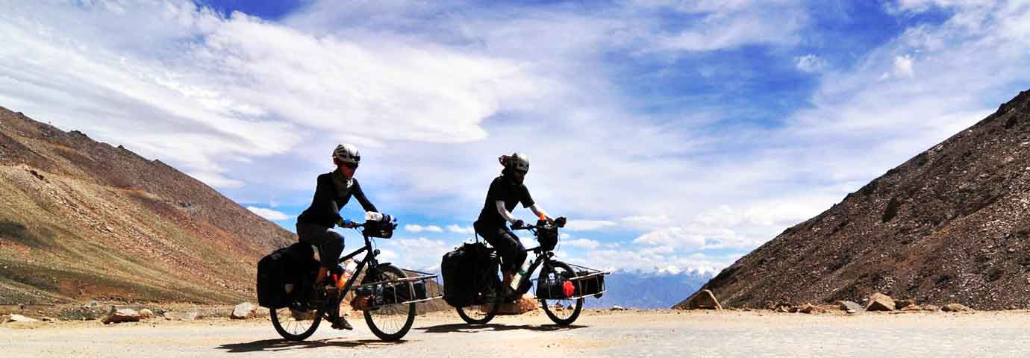

1. [Home](https://www.tourism-of-india.com/)

1. [Destinations](https://www.tourism-of-india.com/travel-destinations.html)

1. [Jammu & Kashmir](https://www.tourism-of-india.com/jammu-kashmir/)

1. [Ladakh](https://www.tourism-of-india.com/ladakh/)

1. Mountain Biking

Mountain Biking in Ladakh

Ladakh is called the ‘Cradle of Adventure’. Mountain biking is one such exciting adventure. In the dizzying altitudes of the barren cold desert, riding on your bicycle on the rising and falling roads is pure dose of adrenalin.

Mountain Biking in Ladakh offers an exhilarating opportunity of cycling through the highest mountain range in the world, the Himalayas and Karakoram. The spectacular beauty of snowcapped mountains, fascinating Buddhist Gompas and charming local villages, are added pleasures as you traverse on your bike.  To bike the Zig-Zag roads in Ladakh, one needs to be technically perfect. The roads are rough, though paved. The slick road wet from melting snow are tricky enough to make one’s wheel skid. A support car to carry ones luggage comes handy. Proper biking equipment is needed to survive and enjoy the thrilling adventure.

[**[+] Read More**](https://www.tourism-of-india.com/ladakh/things-to-do/mountain-biking-ladakh.html)

Best time for Mountain Biking

The best season and reliable period to plan mountain biking in Ladakh is from late June to the end of August. These months coincide

[https://1913578542.rsc.cdn77.org/images/logo.png](https://www.tourism-of-india.com/)

* [Home](https://www.tourism-of-india.com/)
* [Packages](https://www.tourism-of-india.com/india-tour-packages/)
* [Destination](https://www.tourism-of-india.com/travel-destinations.html)
* [Experiences](https://www.tourism-of-india.com/things-to-do/)
* [Best Time To Visit](https://www.tourism-of-india.com/best-time-to-visit-india/)
* [International](https://www.tourism-of-india.com/international-tours/)
* [Get Quote](https://www.tourism-of-india.com/ladakh/things-to-do/pangong-retreat-camp-ladakh.html)

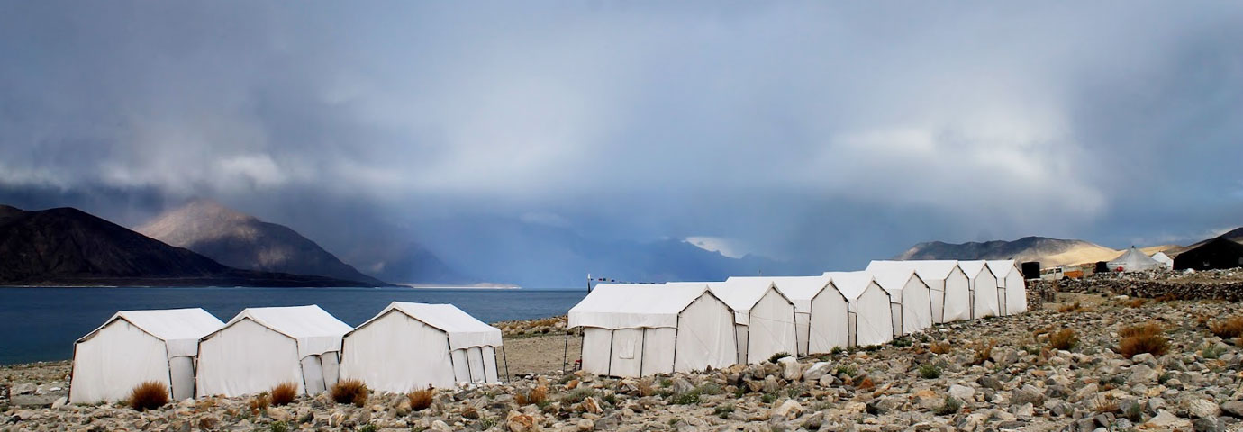

1. [Home](https://www.tourism-of-india.com/)

1. [Destinations](https://www.tourism-of-india.com/travel-destinations.html)

1. [Jammu & Kashmir](https://www.tourism-of-india.com/jammu-kashmir/)

1. [Ladakh](https://www.tourism-of-india.com/ladakh/)

1. Pangong Retreat Camp Ladakh

Pangong Retreat Camp Ladakh

One of the best glamping sites in India, Pangong Retreat Camp is an excuse to enjoy the rustic sceneries of **[Ladakh](https://www.tourism-of-india.com/ladakh/)** in a unique and luxurious way. Set amidst the naked Himalayan Mountains, the camp gives you an opportunity to face off with the captivating nature of Ladakh, without compromising on the luxury quotient.

[https://1913578542.rsc.cdn77.org/images/logo.png](https://www.tourism-of-india.com/)

* [Home](https://www.tourism-of-india.com/)
* [Packages](https://www.tourism-of-india.com/india-tour-packages/)
* [Destination](https://www.tourism-of-india.com/travel-destinations.html)
* [Experiences](https://www.tourism-of-india.com/things-to-do/)
* [Best Time To Visit](https://www.tourism-of-india.com/best-time-to-visit-india/)
* [International](https://www.tourism-of-india.com/international-tours/)
* [Get Quote](https://www.tourism-of-india.com/ladakh/things-to-do/pangong.html)

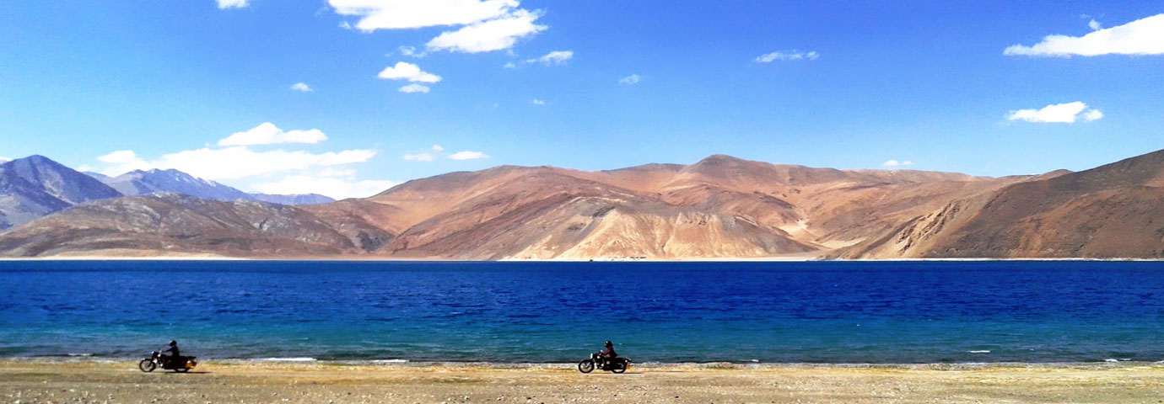

1. [Home](https://www.tourism-of-india.com/)

1. [Destinations](https://www.tourism-of-india.com/travel-destinations.html)

1. [Jammu & Kashmir](https://www.tourism-of-india.com/jammu-kashmir/)

1. [Ladakh](https://www.tourism-of-india.com/ladakh/)

1. Pangong Lake

Pangong Lake

Situated at an altitude of 4,350 meters above sea level, Pangong Lake lies in the northeast of Leh. This famous blue blackish lake of Pangong is 5-6 km wide and over 144 km long with half of it running to the other side of the Indo-China border.

Location

The 160-km trip to Pangong Lake from Leh is an experience of its own. The first stop on the way is Thiksey village famous for its huge monasteries, which cover an entire mountain ridge. Beyond this remote village, there is nothing but the extreme mountain ranges for company. The second stop is the Changla Pass (17,350 ft.), which could test ones lungs, for the lack of oxygen.

Tourists Attractions

At Darbuk village near Tangste Valley stands a chain of war memorials with regimental insignias in commemoration of the soldiers who lost their lives during the Indo-China war of 1962. Some of the army bunkers and trenches are still in use. Villagers can be seen here along with their large herds of Pashmina sheep and long-tailed yaks.

The placid Pangong Lake is not just a tourist's paradise but a geologist's domain too.

Travelers can enjoy the solitude for a day or two, zoom their cameras to shoot the black-necked Siberian crane around the Mahe marshes which are the only breeding ground for these migratory birds. At times, they are seen swarming in the cool colorful water of the lake.

The long and narrow lake lies in the neighborhood of the famous Chushul Mountains. The size of the lake is best inferred from the probable etymology of its name, Pangong, which means extensive concavity. The mirror-calm water is cold, clear, and extremely salty, holding sufficient quantity of lime to form a calcareous deposit, which cements the pebbles together in patches of concrete on its bank. It is believed that there is a large amount of minerals in the basin of the lake, which result from the melting of the snow. The water sparkles in distinct shades of blue, green, purple, and violet, being transparent to a good depth. With ease, one can pick pebbles from under the water, and if one is lucky enough, a fossil shell in the clay deposits may be a rewarding find.

[**[+] Read More**](https://www.tourism-of-india.com/ladakh/things-to-do/pangong.html)

How To Reach

Regular flights go to Leh from Delhi. Once in Leh, one can hire a taxi to Pangong Lake. Otherwise, one can make arrangements with some travel agencies, which are ever ready to take one on a trip to the saltwater lake of Pangong Tso.

One can also take the motor route of Delhi-Manali-Jispa-Darcha-Sarchu-Leh-Khardungla-Pangong.